# Entity Relationship Diagram

**Document Title:** ER - Diagram  
**Activity ID:** M2.3  
**Date: 16/04/2025**   
**Project Team ID:** TP706 - S1 - Team2  
**Project Team Name:** Team 2

Description :

This document captures the different entities and their relationships as shown in the next section.

## ER - Diagram

## Amazon Review 2023

Fake Review Detection Dataset (Small)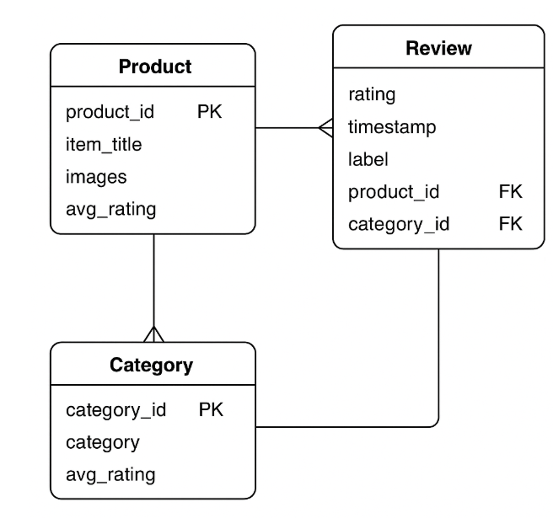

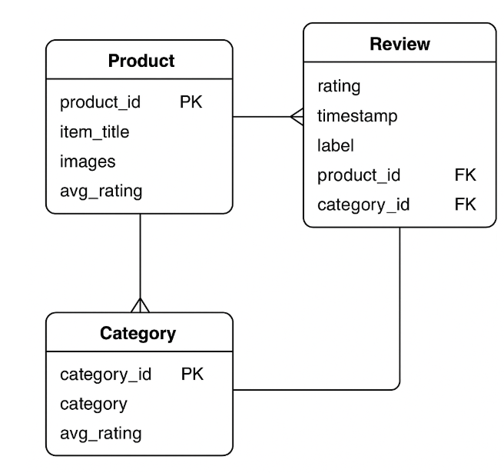

## 2. Remarks / Notes